CPSC 335 7/19/2021

- Passcode: 9cQW^y&h
- Reversing Linked and Doubly Linked lists
  - Two methods
    - Iterative method: use a loop (for/while/do-while) to do the reversal
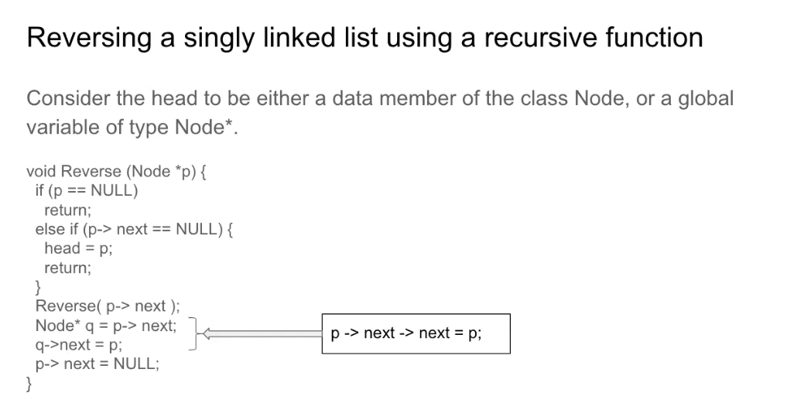
      - head could be global variable or, if not, needs to be passed on
      - if pointer reaches next in list, becomes NULL b/c you are reversing the list.
      - Eventually, each poitner becomes the next head of list until you reach the tail.
    - Recursive method: use some recorusive functions to do the reversal
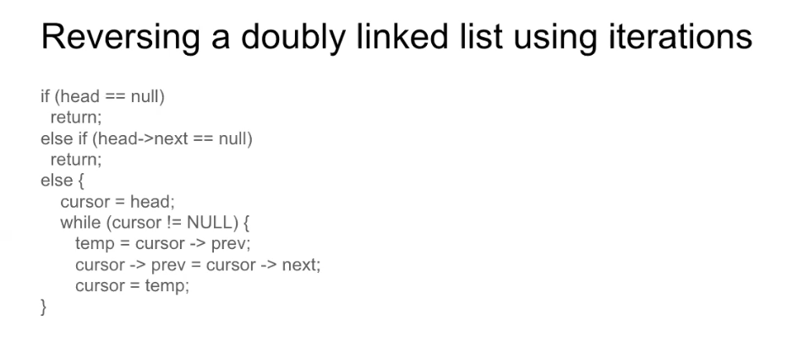
      - Check whether head of list is NULL, do nothing
      - If there is a single element, do nothing
      - IF there is a doubly linked list, need to play with the pointers.
        - As long as you don’t have nothing in either one, prev = next, next = prev
      - Let’s consider this: what happens if we swap values instead of pointers?
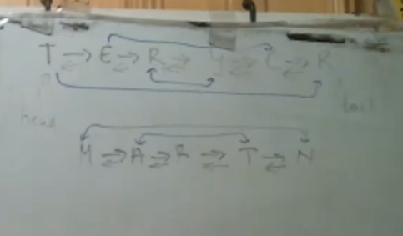
        - Ex.
head and tail are global variables
          - Without creating a new object, if we swap the two values (head and tail), we can reverse the list without changing the pointers.
    - Consider the struct/class Node to be the data type for an element in the list
  - Homework 2 Solutions
    - 4.3 Reversing doubly linked list by swapping values
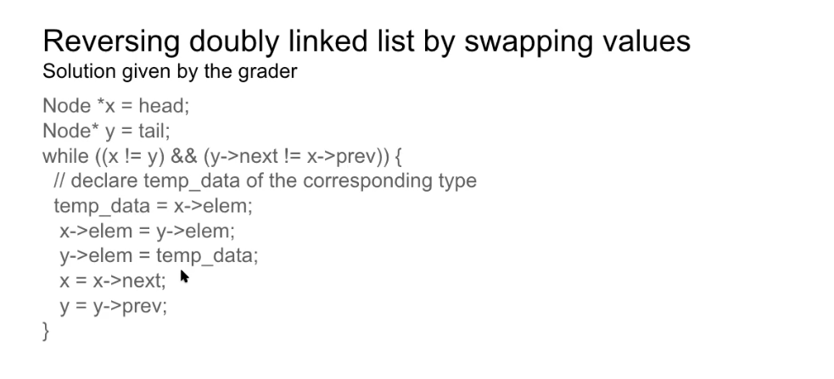
    - HW 4.6 (write a queue)
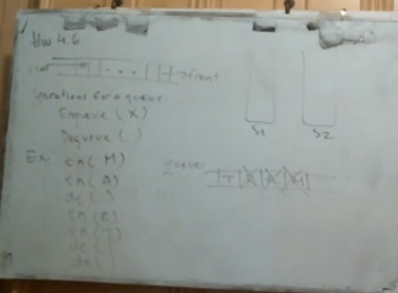
      - Now adding a stack
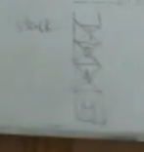

      - You put the data into the stacks
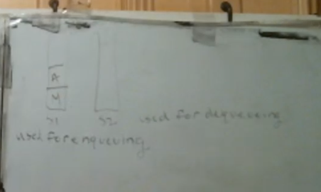
      - Then you start pushing by taking A and M into the next stack
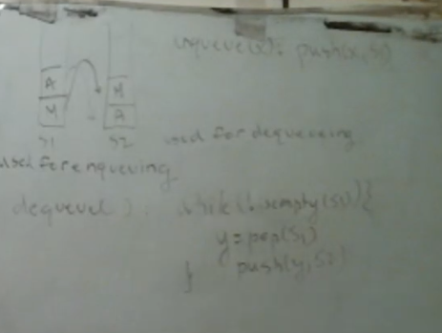

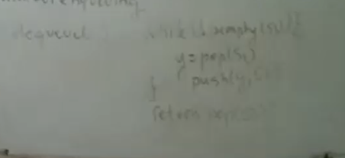
      - Then pop from the stack which returns
      - However, queueing doesn’t correctly stack it
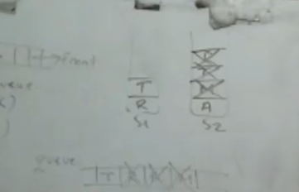

      - Correct code
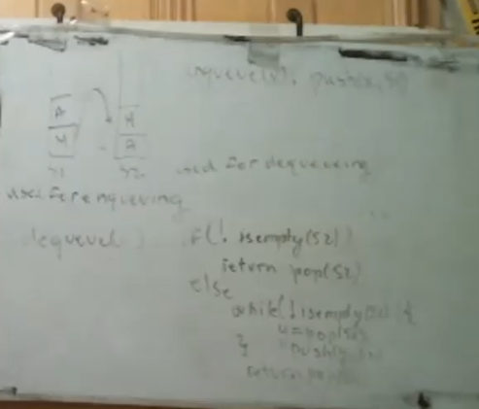
      - Time complexity
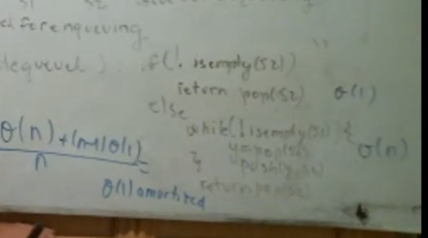
      - a
    - Amortization
      - We are not covering this in the quiz or exam but you need to know how to implement a data structure for another.
  - HW 4.11
    - Study self-balancing trees, specifically AVL trees.
    - Study Graphs
    - From ch.5, solve sequence using selection sort.
    - Select minimum, sort, swap, and do it until original sort is empty.
  - Ex. 5.9 Selection Sort
    - What happens to time complexity?
    - It doesn’t change but no swaps.
  - Ex. 5.10
    - Sorting and reverse sorting
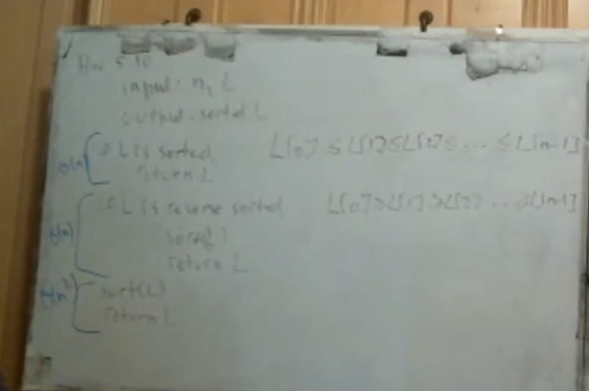
    - We need to test both sorting and reverse sorting
    - 45:51
- Bubble Sort
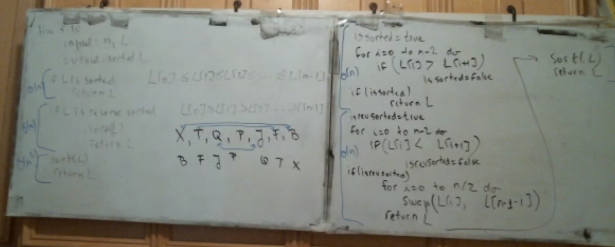
  - Homework 3 is useful for the exam
- Prim’s Algorithm (1:14:10)
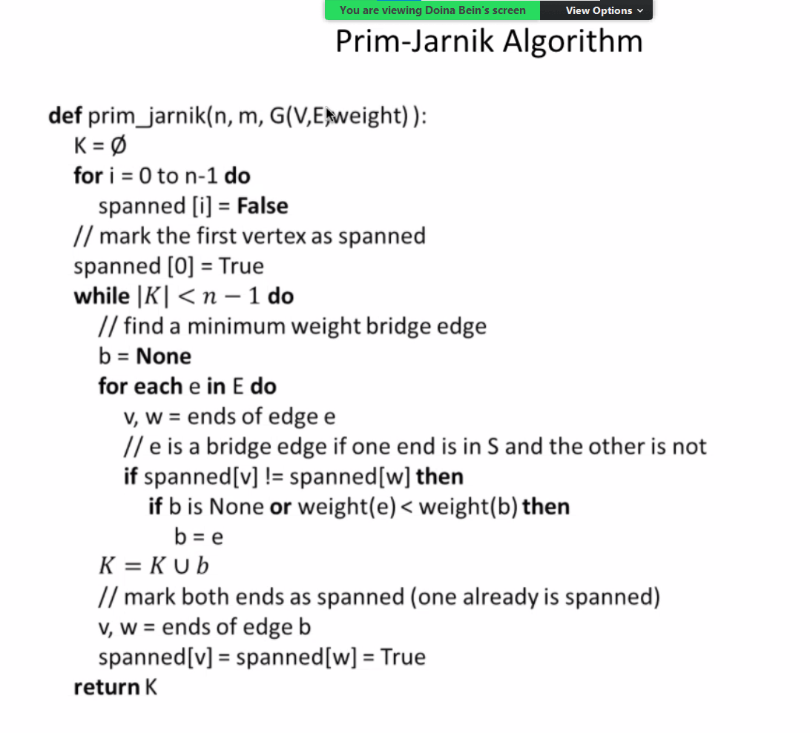
  - Prim-Jarnik Algorithm
    - We start with an empty set
    - Then the first entries into the array are false. So span of I = true if in set S
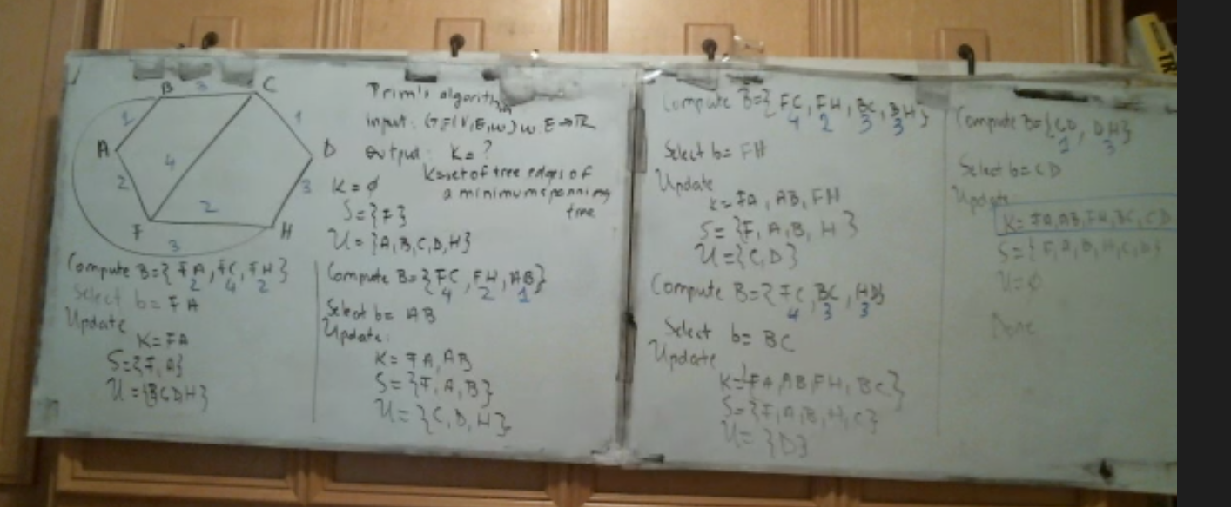
    - g
    - Graphs
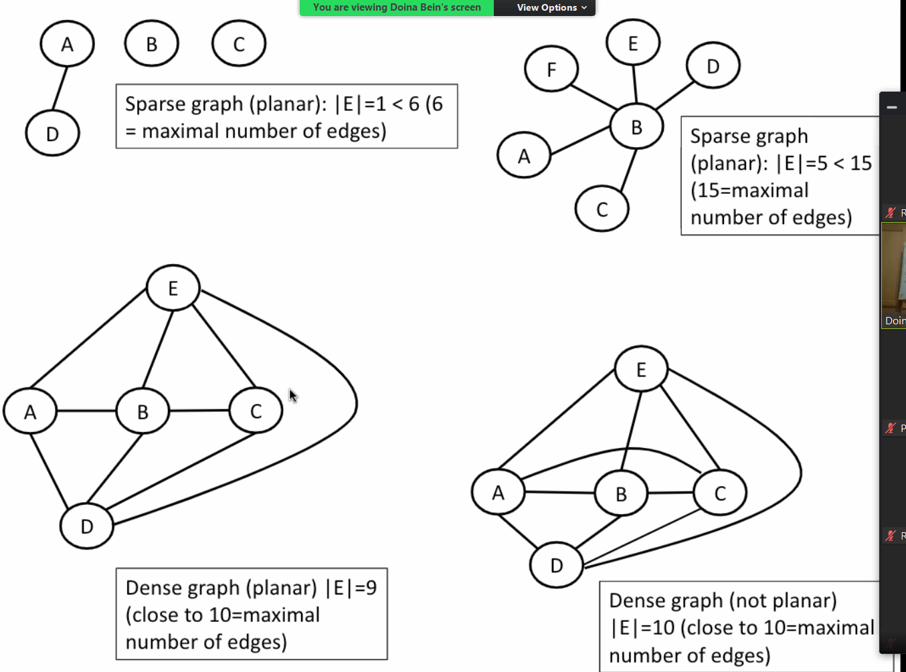
    - g
